Lab 4 results

Abdulrahman

Zaid

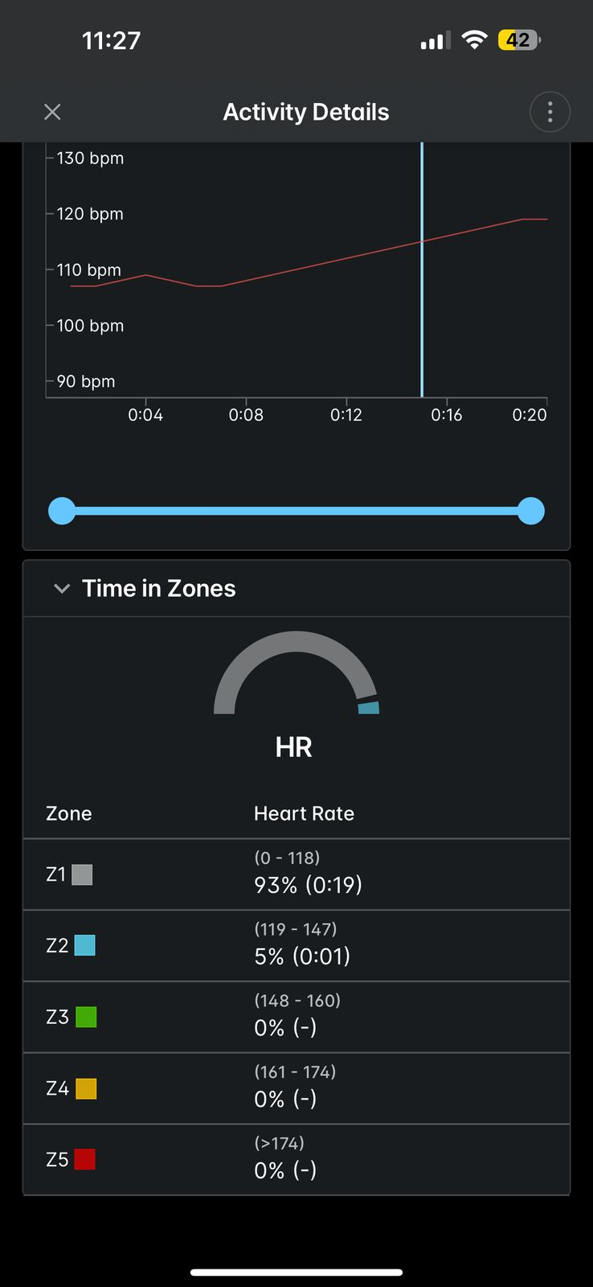

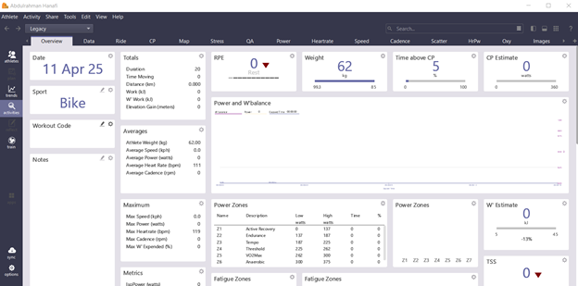

**Python Script (Google Colab Compatible)**

****import pandas as pd

import numpy as np

import matplotlib.pyplot as plt

from scipy.signal import butter, filtfilt

# Load CSV data

data = pd.read_csv('/content/2025-04-11-070201-WAHOOAPPIOSB118-1-0-record.csv')

# Display original data

plt.figure(figsize=(10, 4))

plt.plot(data['heart_rate'], label='Original ECG Signal')

plt.title('Original ECG Data')

plt.xlabel('Sample Number')

plt.ylabel('Heart Rate (bpm)')

plt.legend()

plt.show()

# Add Gaussian noise to data

noise = np.random.normal(0, 2, len(data['heart_rate']))

data_noisy = data['heart_rate'] + noise

# Display noisy data

plt.figure(figsize=(10, 4))

plt.plot(data_noisy, label='ECG Signal with Noise')

plt.title('Noisy ECG Data')

plt.xlabel('Sample Number')

plt.ylabel('Heart Rate (bpm)')

plt.legend()

plt.show()

# Low-pass Butterworth filter

b, a = butter(N=2, Wn=0.1, btype='low', analog=False)

data_filtered = filtfilt(b, a, data_noisy)

# Display filtered data

plt.figure(figsize=(10, 4))

plt.plot(data_filtered, label='Filtered ECG Signal')

plt.title('Filtered ECG Data')

plt.xlabel('Sample Number')

plt.ylabel('Heart Rate (bpm)')

plt.legend()

plt.show()

